training 1 epoch...

288.99400782585144 seconds used......

1 training finished! average train loss: 0.6825978128533614

total clf loss: 159.8648878633976 total adv loss: 84.65172893740237

evaluating...

Confusion matrix, without normalization

[[ 234 43 17]

[ 863 2901 57]

[ 115 24 703]]

Normalized confusion matrix

[[0.79591837 0.1462585 0.05782313]

[0.22585711 0.75922533 0.01491756]

[0.13657957 0.02850356 0.83491686]]

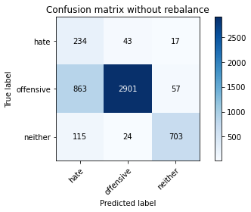

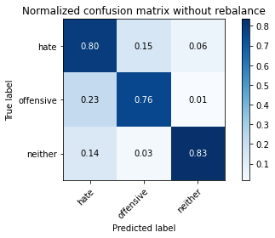

precision recall f1-score support

hate 0.19 0.80 0.31 294

offensive 0.98 0.76 0.85 3821

neither 0.90 0.83 0.87 842

accuracy 0.77 4957

macro avg 0.69 0.80 0.68 4957

weighted avg 0.92 0.77 0.82 4957

average eval_loss: 0.5803684191581345, accuracy: 0.7742586241678434

training 2 epoch...

288.32357478141785 seconds used......

2 training finished! average train loss: 0.39131429454867256

total clf loss: 91.68498565256596 total adv loss: 49.30652782320976

evaluating...

Confusion matrix, without normalization

[[ 249 31 14]

[1013 2737 71]

[ 78 16 748]]

Normalized confusion matrix

[[0.84693878 0.10544218 0.04761905]

[0.26511384 0.71630463 0.01858152]

[0.09263658 0.01900238 0.88836105]]

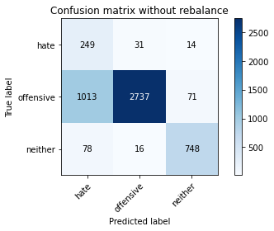

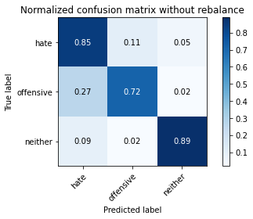

precision recall f1-score support

hate 0.19 0.85 0.30 294

offensive 0.98 0.72 0.83 3821

neither 0.90 0.89 0.89 842

accuracy 0.75 4957

macro avg 0.69 0.82 0.68 4957

weighted avg 0.92 0.75 0.81 4957

average eval_loss: 0.5464060914750546, accuracy: 0.753278192455114

training 3 epoch...

288.4801092147827 seconds used......

3 training finished! average train loss: 0.2826593263777332

total clf loss: 66.52838902547956 total adv loss: 41.64124967157841

evaluating...

Confusion matrix, without normalization

[[ 212 52 30]

[ 623 3027 171]

[ 32 9 801]]

Normalized confusion matrix

[[0.72108844 0.17687075 0.10204082]

[0.16304632 0.79220099 0.04475268]

[0.03800475 0.01068884 0.95130641]]

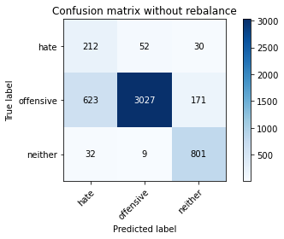

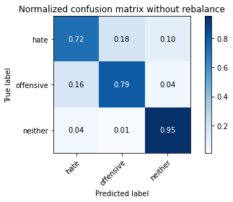

precision recall f1-score support

hate 0.24 0.72 0.37 294

offensive 0.98 0.79 0.88 3821

neither 0.80 0.95 0.87 842

accuracy 0.82 4957

macro avg 0.67 0.82 0.70 4957

weighted avg 0.91 0.82 0.84 4957

average eval_loss: 0.4793691911377305, accuracy: 0.8150090780714142

training 4 epoch...

288.43371057510376 seconds used......

4 training finished! average train loss: 0.18313294962832802

total clf loss: 43.69586189649999 total adv loss: 38.83098641782999

evaluating...

Confusion matrix, without normalization

[[ 208 61 25]

[ 524 3200 97]

[ 38 32 772]]

Normalized confusion matrix

[[0.70748299 0.20748299 0.08503401]

[0.13713688 0.8374771 0.02538602]

[0.04513064 0.03800475 0.91686461]]

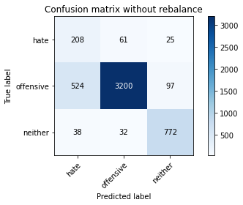

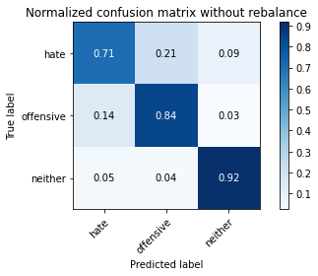

precision recall f1-score support

hate 0.27 0.71 0.39 294

offensive 0.97 0.84 0.90 3821

neither 0.86 0.92 0.89 842

accuracy 0.84 4957

macro avg 0.70 0.82 0.73 4957

weighted avg 0.91 0.84 0.87 4957

average eval_loss: 0.4447215889746554, accuracy: 0.8432519669154731

training 5 epoch...

288.5393180847168 seconds used......

5 training finished! average train loss: 0.10913339976564441

total clf loss: 26.71170196402818 total adv loss: 36.58573443349451

evaluating...

Confusion matrix, without normalization

[[ 240 41 13]

[ 967 2798 56]

[ 84 36 722]]

Normalized confusion matrix

[[0.81632653 0.13945578 0.04421769]

[0.25307511 0.73226904 0.01465585]

[0.09976247 0.04275534 0.85748219]]

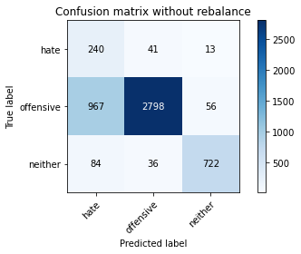

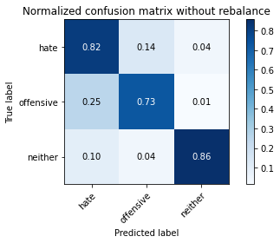

precision recall f1-score support

hate 0.19 0.82 0.30 294

offensive 0.97 0.73 0.84 3821

neither 0.91 0.86 0.88 842

accuracy 0.76 4957

macro avg 0.69 0.80 0.67 4957

weighted avg 0.92 0.76 0.81 4957

average eval_loss: 0.7249190507687381, accuracy: 0.7585233003832963